Copy the entire HTML folder somewhere on your system. For us it’s a subdirectory at the same level as the resources directory

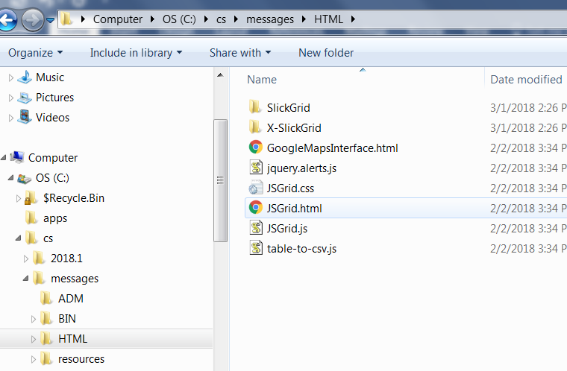

Add these two logicals to your asn. One is the folder to find the HTML directory, the other is a temporary place to put the CSV file for the excel functionality

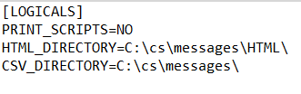

Import the model and slickgrid form. The model is just dict with two extra non-database entities (XXX1, XXX2). From dict I am only using usource.

Import in messasges that you use from your application and compile everything (/all switch).

Bring up the slickgridsdemo and run the test. Note that the messages that are retrieved start with “MSG_” because that is our naming standard, you will likely have to change that. In addition the list of languages that are supported is hard coded to the ones we support.

Run the application and hit the “Go” button. You can hit the debug checkbox to make it start the debugger if you would like to step through the code.

You can hit the “Excel” button to dump everything in the grid to excel.

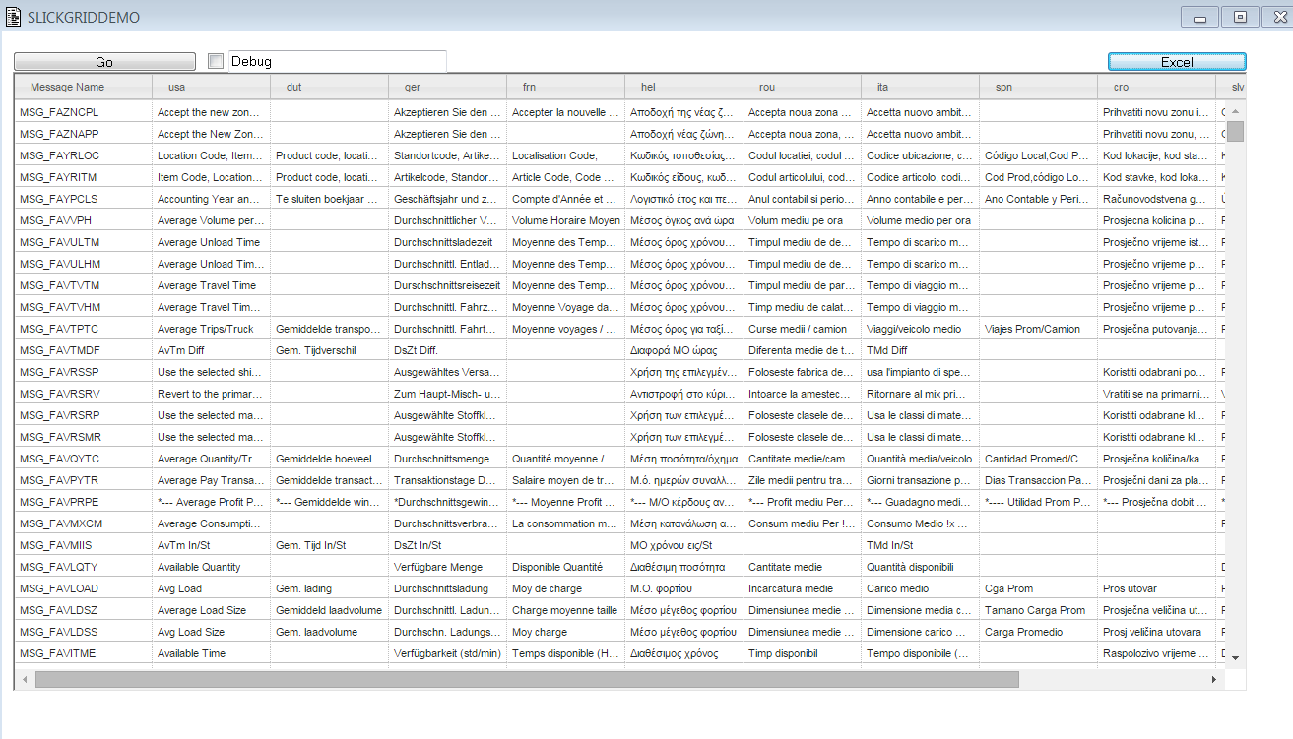

Please look at the JS file to see all the functionality the grid supports. You can have greyed out cells, change the color of cells, free columns so the user cannot move them, have buttons\dates\numbers\dropdowns inside cells.